My new Queer life
@rachelbrindell

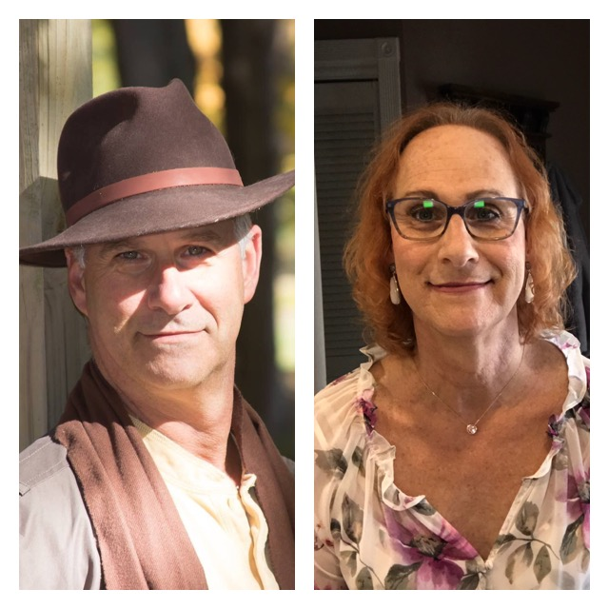

So here I am 62 years old. Came out as trans after 60 years of deep denial. Transition began two years ago.

Starting over. Yes, like so many others my wife of 30 years left me. Oh, maybe not exactly why you think. You see she was diagnosed with cancer the year before my egg cracked. I can go on about how hard it all was transitioning during her struggles especially the last few months when she suffered greatly, but that it is not what I’d like to relay in this piece.

Rather I’d like to share my thoughts and emotions looking forward. I feel completely alone and I am frightened. I am queer. It took me long enough to figure that one out. I always thought of myself as fairly astute but I suppose I was completely blind when it came to myself. I was socialized and (yes let’s call it like it is) brainwashed to be the male everyone expected. I was damn good at that cis-normative life. I could have won an Oscar.

But yet, I don’t know how to be queer. I know in my heart that my cis family and friends can never understand what it’s like to be trans. Only other trans folks can really understand, right? I long for community. Oh, sure I have cis allies but while they try their best to be supportive I still feel that disconnection.

I’ve lost too. Some family members seem to disagree with my transition. Ask me if I care. Go ahead, please. Yes, it bothers me I have lost them, but I am sure you have heard the mantra, I have gained so much. And that is true.

But it doesn’t change the fact. I do not know how to be queer. Shouldn’t there be a handbook that gets sent to you when you change your gender marker at the DMV? Furthermore, I am quite disappointed there was no fanfare after I came out. No parade, not even a free blender or toaster. This was such a momentous occasion, but the only people I had to share this with were people who could never understand.

I feel unloved. Think about it. Everyone who has loved me up to this point loved my façade persona. That cis-normative male entity I used to hide behind. Oh, he had some good qualities but he was a sham. Loved yes, but a sham all the same. I used to tell so many people after I first came out that I was still the same person I always was. But I was wrong. I have changed, in many ways. Physically, emotionally and mentally. I see it clearly now. Before it was obscured by fog. That fog has lifted and I am who I was meant to be.

No one who loved the protector entity knows the real me. Therefore, they cannot love me. So now I am unloved. A loveless empty vessel waiting to be filled. I hope to meet people who didn’t know me who may learn to love me. I deserve it. I did not expect this void. This is where the loneliness comes from. Shall I ever be loved again?

I’m scared. I’m alone. I’m unloved. Yet I feel so full of life. I want to experience all my new queer life can offer. I want to help others like me. I want to give to the community. I want the community to give to me. But I find that while my individual and group therapy has gotten me to this point, I must take that next step alone. But I really don’t know how to go about it. It’s intimidating.

I have a few months to plan, as I am retiring from my 35-year insurance career in a few short months. That scares me too. Socially, I know my future is not with my long-time couples’ friends. It can’t be. I am no longer like them, and I’m no longer a couple, just that third wheel no one ever wants to be, and a queer third wheel at that. Don’t get me wrong here. I want you to know I very much love being queer. I no longer have to subscribe to society’s expectations of me, and I am free. But my freedom at this point is infantile in as much as I am a toddler at best, trying to learn to walk, speak and act any way I choose, and I have not chosen yet. So now my focus turns to our community for love and support. I need you. I can’t do this alone.

I am a trans-lesbian stuck between the hetero-normative hell of my past and an uncertain queer future I know nothing about. I wonder will I ever be loved for the person I was meant to be all along? I hope so because I have so much to give. Love, respect, fierce loyalty, laughter and fun, and an intimacy I have never allowed myself to feel before.

Am I the only one who feels like this? Did I miss the queer crusade that I should have been on when I was younger, fighting alongside those other trans-pioneers? I feel like I have missed so much in my life that I can never make up for. The sixty-year silence in my closet was deafening. The walls were screaming at me, but I never heard them.

I know that I am the only person responsible for my own happiness, and I will find a way to make the most of my future, but for now I remain full of trepidation and uncertainty.

The path is ahead me, I will follow it wherever it leads like a unicorn adrift in a rainbow continuum.

